Vibration monitoring system
Technical Description

Table of contents
I. Introduction 2
II. Requirements 4
II. 1. Devices and data collection 4
II. 2. Data storage 4
II. 3. Data processing 5
III. System specification 5
IV. Offer 7
Bibliography 7

2018.02.15.

- Introduction
The primary mission of the ELI-ALPS Szeged research facility is to make a wide range of ultrashort light sources accessible to the international scientific community user groups. Laser driven secondary sources emitting coherent extreme-ultraviolet (XUV) and X-ray radiation confined in attosecond pulses is a major research initiative of the infrastructure. For a detailed description of research activities see: www.eli-alps.hu .
The laser beams will be propagated over a path length of tens of meters with the help of the Beam Transport Line (BTL) integrating the primary and the secondary laser sources.
The optical mirrors which tend to guide the beams by reflecting them in the right direction are placed on rigid optical support anchored to the floor. These mirrors are situated inside vacuum chambers, which are attached to the floor of the building using vibration isolated chamber supports. Since two mirrors can cover a great distance, keeping displacements caused by vibrations on a low level is a matter of great concern. For this reason, the base of the experimental area was designed to fulfill the vibration criteria class VC-D [Ref 1., and 1. Figure] which defines a maximum of 6 µm/s acceptable RMS vibration velocity level in 1/3 octave bands between 1-100 Hz in each direction (x,y,z).
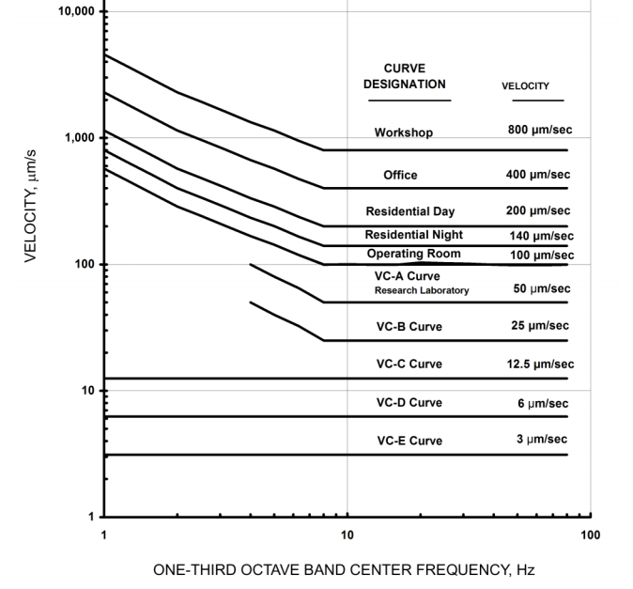
1. Figure – VC Curves
The base (measuring 74x74 meters) is vibration decoupled from the ground, from the outer shell of the building and from supporting systems location on the engineering bridge, as you can see on the schematic drawing of the experimental building on Figure 2.
The task is to design and implement a vibration monitoring system including several sensors. The system shall be installed on the vibration free basement to allow evaluation of vibrational conditions
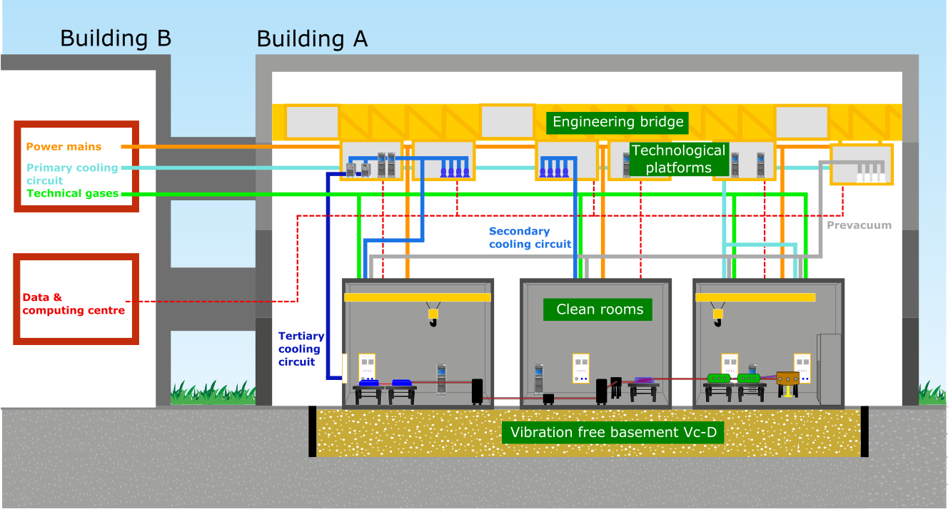
2. Figure – Cross section of experimental building
Vibrational data from the sensors should be collected synchronously in a centralized system. This system shall be able to store and process data, supply real time vibration data stream for other systems, create seismogram-like time plots and spectrograms.
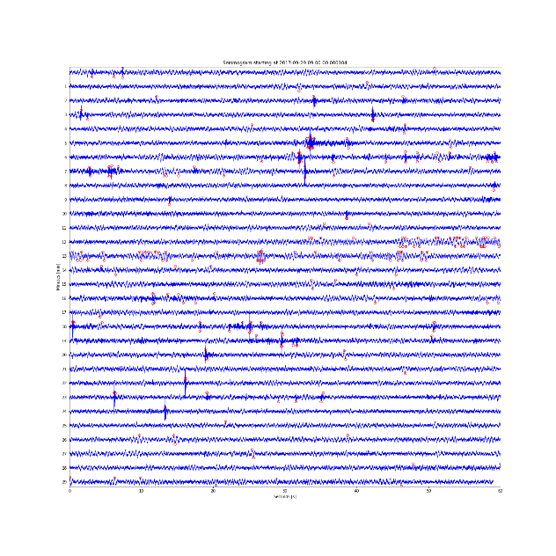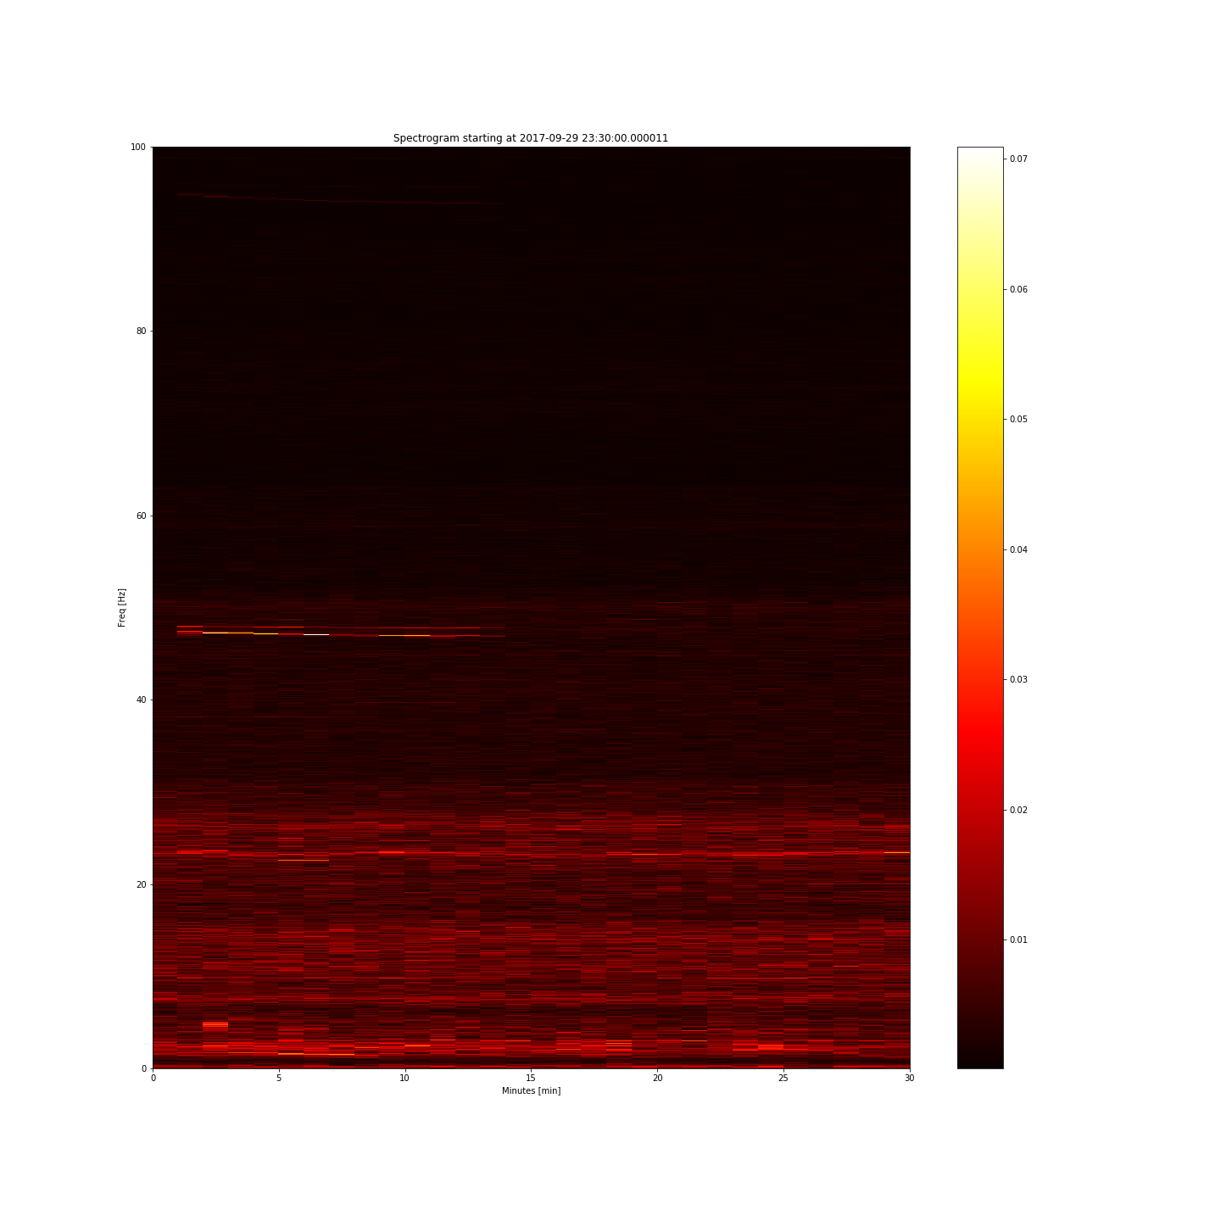
3. Figure – Example images of processed data: seismogram-like time plot (left) and spectrogram (right)
Historical data and processed data shall be accessible from outside the system (e.g. through web service or through a plain file share), for archiving purposes.
- Requirements
  - Devices and data collection
- Measurement of vibration in range of 1 – 500 Hz, optionally 1 – 1 kHz
- Sensitivity range for vibration velocity about 0.05 – 10 000 µm/s
- Signal-to-noise ratio: 30 dB +/- 10 dB (5 Hz sinusoidal vibration at 6 µm/s RMS velocity amplitude compared to 1-100 Hz integrated RMS velocity amplitude)
- Sampling simoultaneity between 200 ms – 20 µs
- Measurement system should be able to evaluate VC-E criteria [1. Ref]
- Vibration velocity and displacement data collection from sensors with timestamps
- Total number of 35 sensors, but expandable up to minimum 64 sensors
- 25 sensors only for Z axis (ground normal), and 10 of them should be tri-axial (see Figure 5.).
- Continuous operation and recording
- Data processing: seismogram like plot images and spectrogram plot images (Figure 3.).

  - Data storage

- Redundant storage shall be included into the system aiming two reasons: offline storage of historical raw data, offline storage of processed data
- Historical raw data should be stored for minimum of 6 weeks for 35 sensors
The monitoring system should operate without interruption. It shall be able to record the at least 24 hours per day, for 7 days a week, for 6 weeks altogether.
6 weeks of storage means: it shall store (on built in, or on a separated storage array) at least 6 weeks of raw measurement data, the older data can be deleted automatically.
Any of the sensors are accessible externally, anytime for the last 6 weeks (for example: one should be able to get the raw measurement data of sensor nr. 8, recorded 3 weeks ago, on Monday morning, between 6:00 and 7:00, if one see a suspicious peak on the spectrogram at that time).
- Processed data storage for 1 year for 35 sensors
- Historical raw and processed data should be accessible from outside the system for automated tasks (archiving, display) through Ethernet interface
- Real time or quasi real time (at most 5 sec time period, sending out the waveform of last 5 sec) data streaming for other systems

  - Data processing

- Data processing from raw data: seismogram-like time plot and spectrogram every 30 minutes, real-time 1/3 octave band analysis
- Data processing and interface software should be included in the scope of delivery
- ELI-ALPS will provide UPS back-up for the power outlet of the system. In case of UPS power outage, the monitoring system should „survive” it without data loss (a small reasonable data loss can be tolerated, for example the last few minutes which was not dumped to the storage disk can be lost, but the operating system should remain healthy), monitoring can be stopped. Monitoring should restart automatically, without human intervention, when the power returns.
- On-Site installation of the system (sensor fastening and installation, cabling with appropriate mechanical protection outside floor channels and cable ties and fasteners inside channels, cable trunking on corridor, data collection system and storage installation) with all related works
- Installation requires working in Clean Room environment ISO7-8. Contractor should bring their own appropriate shoe covers and overalls. Wet drilling is needed if sensor installation requires screw fastening.
- Calibration possibility and initial calibration of the system, with entire measurement documentation and certificates supplied
- SAT (site acceptance test) of the entire system will be evaluated by MR3000C devices of ELI-ALPS
- Detailed documentation of the system (user manual, software manual, implementation plans)

- System specification
Vibration sensors are required to be installed on the critical locations in the experimental building. The approximate sensor locations are marked on Figure 4:
- At primary sources
- At Beam Transport Line mirrors
- At secondary sources
- At end user stations (total 20-30 sensors altogether for these 4 categories, uni-axial: and tri-axial: marks on 4. Figure)
- On the corridor between the building outer shell and vibration free basement (1-4 sensors, marks on 4. Figure, tri-axial)
- Outside the building installed on a concrete pile available (1 sensor, mark on 4. Figure, tri-axial)
- Under the vibration free basement, inside the building’s vault (1 sensor, mark on 4. Figure, tri-axial)
Total number of sensors for the whole system is 35, but it shall be expandable and flexible, to allow connection of further sensors – maximum 64 (i.e. extension possibility of 29). Cabling can be routed using floor channels available at 5x5 m square raster across the whole vibrations free basement (see 4. Figure). Central data collection units can be located in Laser Control Room (LCR – see 4. Figure, icon ).
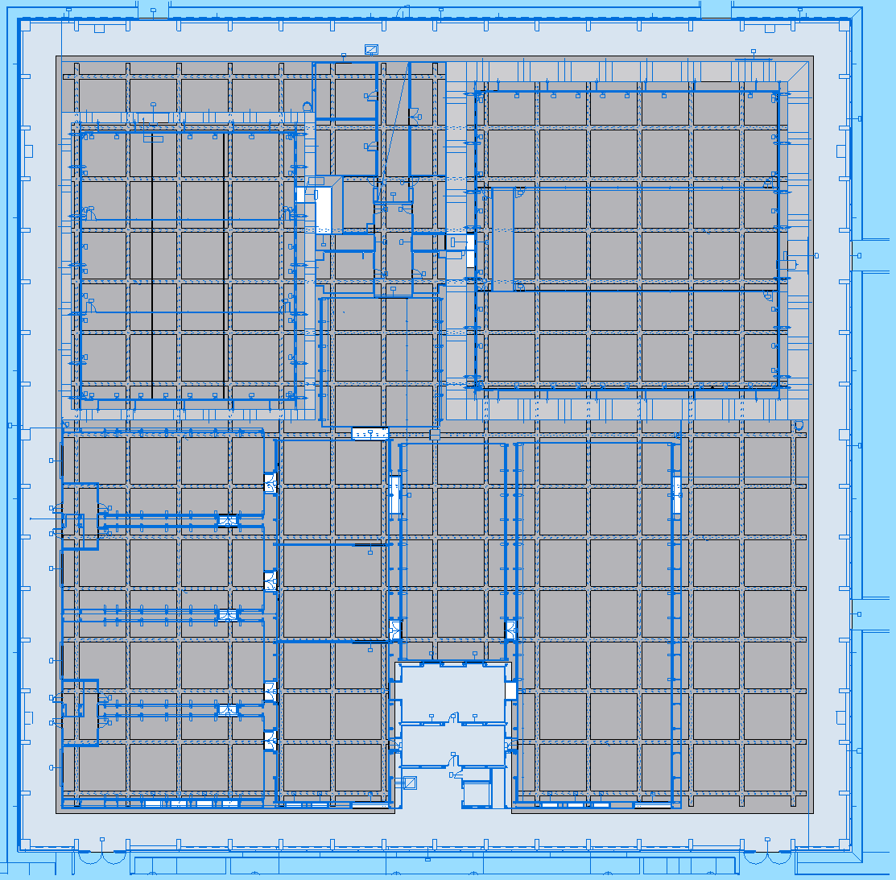
Corridor
LCR
Floor channels
4. Figure – Scientific infrastructure floor map of ELI-ALPS, with approximate positions of sensors – preliminary physical system plan
…
x 25 uni-axial sensors

…
x 10 tri-axial
sensors

External communication
Storage
Data collection
Graphical User Interface
Ethernet interface
5. Figure –Preliminary logical system plan

- Offer
- The bidder shall define as part of his bid the technical description of the proposed system’s devices (demonstrating that these devices satisfy the technical specifications given above)
- The bidder shall provide as part of his bid the description of the system’s software, as well as the method of data access

Bibliography
[1.] American Society of Heating, Refrigerating and Air-Conditioning Engineers, ASHRAE 2011 Handbook, HVAC Applications „Chapter 48: Noise and Vibration Controll” Fig. 41.

